**Terms of Reference:**

**Communications/Business Development Volunteer at CUBIC**

**Background**

Save the Children is the world’s leading independent organization for children, working in 110+ countries. In April 2020, Save the Children launched the [Center for Utilizing Behavioral Insights for Children (CUBIC)](https://www.cubic-sci.org/) in Asia. CUBIC is the first “nudge unit” in the world to focus specifically on the most marginalized children’s rights and welfare. Our goal is to create change for the world’s most marginalized children by applying behavioral science, and we have now delivered more than 50 projects globally, using behavioral science to enhance impact for children. 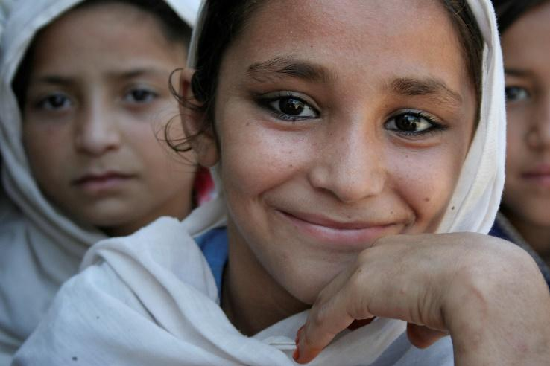

**Projects**

CUBIC is seeking a volunteer with or currently obtaining their Master’s degree, or someone in their early career, to support our communications and business development strategy. We have a new communications strategy aimed at increasing our brand awareness and profile, and within this we need to produce engaging briefs/blogs on our work, increase our social media presence, and identify speaking opportunities.

**Volunteer Objectives**

The volunteer will be integrated into the 12-person remote CUBIC team and will have the opportunity to get involved in multiple projects – the expectation for the volunteer is that s/he would primarily contribute to:

1. **Social media posting**:

* Support the implementation of our social media plan
* Create social media content based on team’s activities and projects
* Manage/support a team site on LinkedIn and other social media platforms

1. **Drafting and editing impact briefs**:

* Using project reports/materials and through talking to project leads, draft overviews of completed CUBIC projects, conveying the project purpose and outcomes in a concise and compelling way.
* Draft blogs/ briefs for the project leads to approve and share.
* Provide editorial support for project reports and presentations.

1. **Supporting other New Business/Communications activity**:

* Support the New Business Development Lead with development of proposals and concept notes
* Provide editorial support for project reports and presentations
* Conduct research on prospective donors identified for CUBIC funding, investigating their priority investment areas and alignment with CUBIC’s approach.
* Identify a calendar of relevant conferences and events, plus abstract submission timetables

**Skills Required**

* Enrolled in/or recent graduate of Master’s/early career in communication, journalism or media
* Interest in and experience of using social media for marketing
* Interest in and (ideally) experience of content marketing strategies
* Strong written communication skills
* Interest in communication of science/science journalism, and the ability to think creatively about presentation of data and project results
* Strong collaboration and teamwork skills

**Time Requirements**

* **Part time Volunteer**. Expectation is for 8-12 hours a week, for a minimum of 6 months.

**Supervisor**

CUBIC’s New Business Development/Comms Lead as well as other team members

**Conditions**

The NBD and Communications Volunteer will be engaged on a voluntary basis (non-paid) and will sign a volunteer contract with Save the Children. The schedule will be determined by the volunteer; however, attendance during regular team calls and calls with our country partner teams will be important.

**Location**

Remote/home-based

**How to Apply**

Please apply online through the Save the Children portal. Application will require a CV and cover letter. For more information about CUBIC please visit our website: [www.cubic-sci.org](http://www.cubic-sci.org)